**Update to version 2 app**

Follow the steps given below to update your Deployment:

1. Let's update the image to version 1

kubectl set image deployment.v1.apps/python-deployment python-container=anilbidari/python:v2



**Step 2 : verify app v2 image is used for deployment**

# kubectl describe deployment python-deployment

**Step 3 : Describe svc**

# kubectl get svc

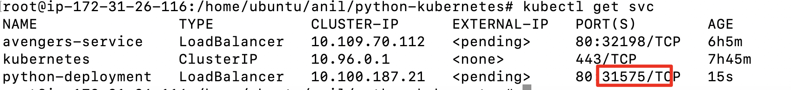

Use the PublicIp-ofmaster-node:31575 on your web browser to verify app is running

**Step 4 : List the replica set**

# kubectl get rs

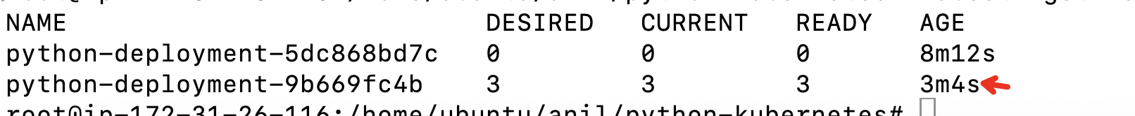

Rolling Back to a Previous Revision

Follow the steps given below to rollback the Deployment from the current version to the previous version, which is version 2.

1. Now you've decided to undo the current rollout and rollback to the previous revision:

kubectl rollout undo deployment/python-deployment

**Step 3 : Describe svc**

# kubectl get svc



Use the PublicIp-ofmaster-node:31575 on your web browser to verify app is running

Get the description of the Deployment:

kubectl describe deployment python-deployment

============================ completion of Lab =======================================